|  |  |
| --- | --- |
| *A transdisciplinary approach to Art* | BROKEN HILL ART EXCHANGE  PO BOX 1083  BROKEN HILL  NSW 2880 AUSTRALIA  PH:+61 8 8088-3171  ABN: 33 892 538 379  [www.brokenhillartexchange.org.au](http://www.brokenhillartexchange.org.au)  [info@brokenhillartexchange.org.au](mailto:info@brokenhillartexchange.org.au) |

**RESIDENCY PROGRAM APPLICATION FORM**

*The* ***Broken Hill Art Exchange Inc.*** *is a not for profit, volunteer and artist run organisation. Supporting the production of art and the progress of artists, it aims to advance art and culture within communities.* ***BHAE*** *encourages transdisciplinary approaches to art through engagement between different sectors such as Health, Education, Environmental Studies, and Science.*

***BHAE*** *provides short and long-term residency to individuals and groups engaged in artistic practices or research. Since its inception in 2001,* ***BHAE*** *has hosted numerous Australian and international painters, writers, film producers, musicians, and designers among others.*

*Australia’s only Heritage City,* ***Broken Hill****, continues to inspire creative minds through its unique outback landscape, remoteness, spellbinding sky and the genuine friendliness of its people. You are bound to hear and take away many fascinating stories if you stay awhile…*





Email

**IF YOU ARE**

**APPLYING AS AN REPRESENTATIVE FOR OTHER/S**

**PLEASE COMPLETE THIS SECTION**

Agent’s full name

Name of your Organisation

**Please note that you will be the main contact for official correspondence, invoicing, etc.**

Address of Organisation

City

State

Postcode

Phone (incl area / country code)

Country

***APPLICANT DETAILS***

Print title and full name

Your Address

Email

City

State

Postcode

Phone (incl area / country code)

Country

***IS THIS APPLICATION FOR A GROUP?***

**Please circle**

**YES or NO**

**IF “YES” Please note that you will be the main point of contact for BHAE during your stay and for all correspondence. Please ensure that all group members are included in section 3**

CONTINUE TO SECTION 2



SOLAR

(fire)

WIND

EARTH

WATER

Please indicate in the box below

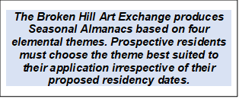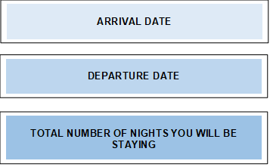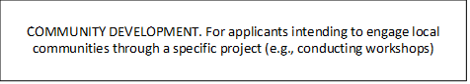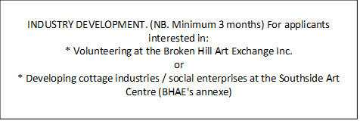

CONTINUE TO SECTION 3





Please circle

YES or NO

Name

Name

**PLEASE PROVIDE 2 REFEREES**

Ph. Incl country & area code

Ph. Incl country & area code

**FUNDING:** Please indicate how your residency fees will be funded by placing ‘X’ in the relevant box and providing details where required.

SELF FUNDED

GRANTS

OTHER

Please provide the full name(s) of the grant(s) or other funding source(s):

**PLEASE PROVIDE AS ATTACHMENTS:**

Your CV and/or biography

A maximum of 4 samples of your artistic work where applicable

URL of uploaded work if available. Include your website address if you have one. (Eg, YouTube, Vimeo, etc)

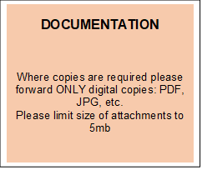

IF MORE SPACE REQUIRED PLEASE CHECK THIS SPACE AND ATTACH LIST TO YOUR APPLICATION

Please insert the full name of each group member accompanying you, and their role.

Eg, John Smith - Actor

CONTINUE TO SECTION 4







CONTINUE TO SECTION 5

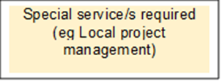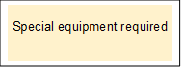

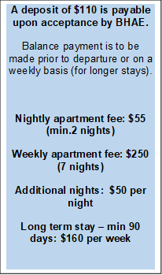

**NIGHTLY**

$55 per night

Min 2 nights

TOTAL COST

Number of nights?

**WEEKLY**

$250 per wk

(7 nights)

TOTAL COST

Number of weeks?

**ADDITIONAL NIGHTS**

$50 per night

TOTAL COST

Number of nights?

**LONG TERM STAY**

Min 90 days

$160 per wk

TOTAL COST

Number of ROOMS?

Number of weeks?

Number of ROOMS?

Number of ROOMS?

Number of ROOMS?

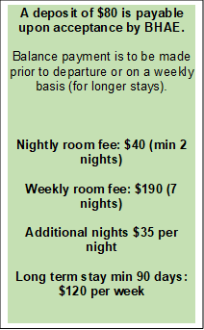

TOTAL COST

**NIGHTLY**

$40 per night

Min 2 nights

Number of nights?

Number of ROOMS?

Number of ROOMS?

Number of ROOMS?

Number of ROOMS?

**WEEKLY**

$190 per wk

7 nights

TOTAL COST

Number of weeks?

**ADDITIONAL NIGHTS**

$35 per night

TOTAL COST

Number of nights?

**LONG TERM STAY**

Min 90 days

$120 per wk

TOTAL COST

Number of weeks?



**CURRICULUM VITAE**

**JPEG SAMPLES OF MY WORK**

**If applying for a 10% concession**

**COPY OF A VALID CONCESSION CARD**

**BIOGRAPHY**

*And / Or*

*With*

*And*

SIGNATURE_____________________________________________

FULL NAME (Please print): _____________________________________________

DATE: _____________________________________________



CONTINUE TO SECTION 7





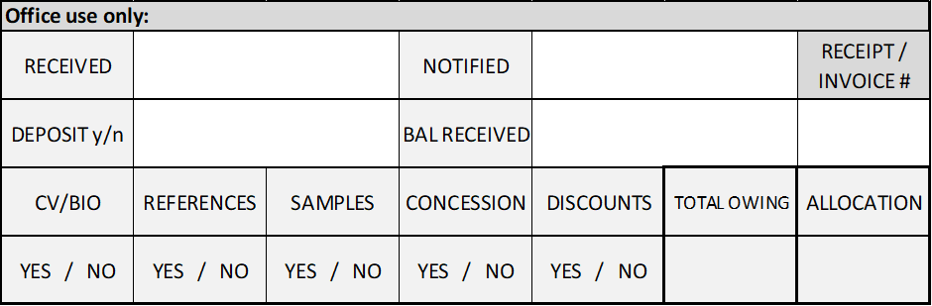

**TELL US A LITTLE ABOUT YOURSELF:**

**TELL US ABOUT YOUR WORK:**

**WHAT INSPIRES YOU?:**

**WHAT ATTRACTS YOU TO BROKEN HILL?:**

**WHAT DO YOU HOPE TO EXPERIENCE IN BROKEN HILL?:**