BHAE Street Art Projects
Street Art Projects: The Street Art Projects comes about as a result of the resounding reception the Exchange received in response to a mural project done by visiting artist Damien Mitchell. Both local businesses, organisations and artists have expressed interest in creating a mural for their own wall and the Art Exchange shall deliver! In conjunction with an international assemblage of visiting artists and local artists across BH and the region. BHAE will ensure that the right artist is selected for the right job.

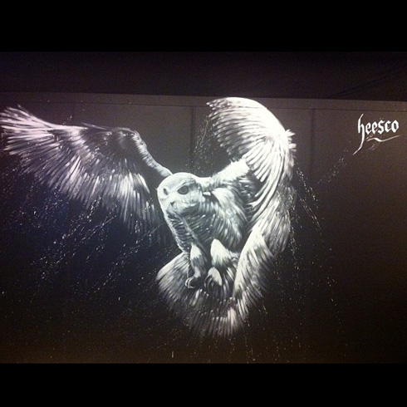
Street art is far from just the stereotypical fluorescent tags on a trains carriage, it also includes the corporate to the modern & everything in between. This project will focus on street art in the form of wall murals, a form of art with a proven ability to draw positive attention and often publicity.
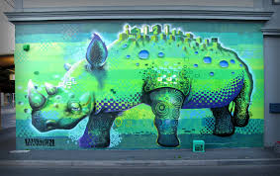
Art by Makatron
There is a material subsidy provided to eligible projects displayed in publicly accessible locations i.e. exterior walls with a street view.
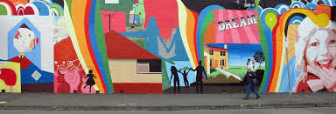
Art by Adrian Doyle

Art by Heesco
The Street Art Project will include individual commissions and/ or the opportunity to register the murals into larger art events. It’s as easy as submitting an application form at the Broken Hill Art Exchange and watch your blank canvas come to life.
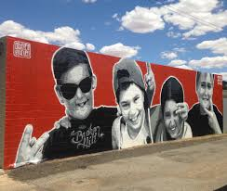
_{Art by Damien Mitchell}

Broken Hill Art Exchange Contact Details:
Address: South Side Art Centre,
145- 157 (Unit 3) Duff St Broken Hill NSW Australia
Phone: (08) 80883171
ABN: 33 892 538 379
Website: www.brokenhillartexchange.com
Email: info@brokenhillartexchange.org.au

Street Art Project
Expression of Interest Registration Form

If you would like a graffiti wall on your premises, please fill in this application form. The artist will be conducting the project for 1 week.

Full name of applicant: ______________________________________________________
Organisation/business name: _________________________________________________
Email: ____________________________________________________________________
Phone: _____________________________ Mobile: _______________________________
Property Address: ____________________________________________________________

Do you reside at the property? YES NO

Property owners name: _____________________________________________________

Size/Dimensions of the wall: ______________________________________________________

Nominated site of wall (specific address/location)
_______________________________________________________________________________

I Confirm, that I have the appropriate permissions from the property owner.
Initial here: ___________

Please tick √
External Internal

Wall surface type (e.g. brick, corrugated iron, cladding panels etc.)
________________________________________________________________________________
*Please email a photo of your wall for the artist to info@brokenhillartexchange.org.au
Would you like some initial input into the design? YES NO
If yes please describe 200 words or less what you would like the artist to achieve:
____________________________________________________________________________________________________________________________________________________________________
__________________________________________________________________________________________________________________________________________________________________________________________________________________________________________________________________________________________________________________________________________________________________________________________________________________________

Thank you for expressing interest in this project. The Broken Hill Art Exchange will contact you as soon as possible to inform you of the results. Should you be successful, a design proposal will be forwarded to you. Once a consensus is reached you will receive a formal Agreement to undertake the project.

Name: ___________________________________________________
(Please print name in full)

Signature: ____________________________ Date: _______________

